VARNA FREE UNIVERSITY
"CHERNORIZETS HRABAR"
FACULTY OF "SOCIAL, ECONOMIC AND COMPUTER SCIENCES"
DEPARTMENT OF "COMPUTER SCIENCES"
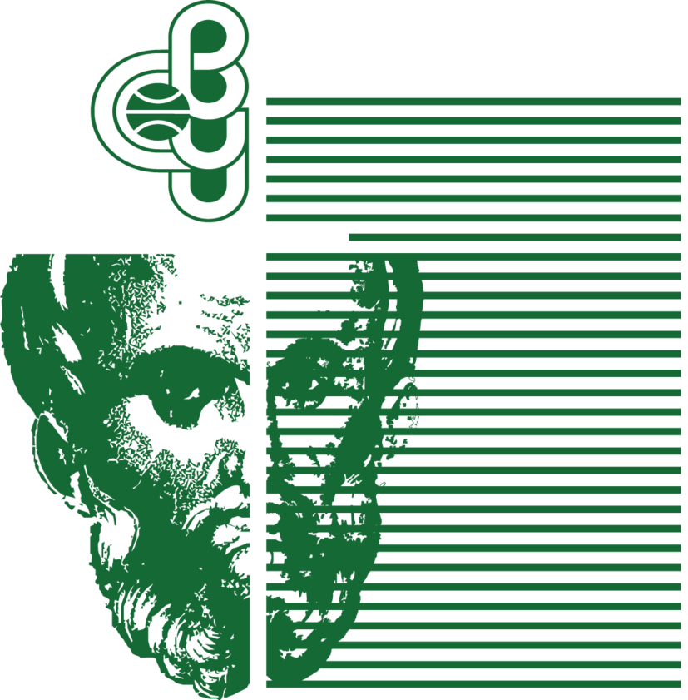
COURSE WORK
on the subject: Programming and Algorithms
on the topic:
Algorithms for finding the shortest path in a graph
Prepared by: | Reviewed by:
Hristo Nikolaev Ivanov | Academic title, name and surname
Student ID: 257330006, first year | /................................/
Major: Software Engineering and Management
Form of study: distance learning

Varna, 2026

TABLE OF CONTENTS
p.
Introduction 3
1. Theoretical part 4
1.1. Presentation of the selected algorithms 4
1.2. Dijkstra’s algorithm 4
1.3. A* algorithm 5
1.4. Bellman–Ford algorithm 6
1.5. Comparison of the algorithms 7
1.6. A closer look at Dijkstra with an example graph 7
2. Example of how the algorithms work 10
3. Software implementation 12
3.1. Implementation of Dijkstra’s algorithm 12
3.2. Implementation of A* with heuristic 13
3.3. Implementation of Bellman–Ford 15
4. Demonstration 17
5. Testing the algorithms 18
5.1 Short distance 18
5.2 Medium distance 19
5.3 Long distance 20
5.4 Summary comparison table 20
5.5 Analysis of the results 21
6. Conclusion 22
7. References 23

Introduction
Shortest-path algorithms are one of the most fundamental concepts in graph theory and computer science. They have applications in many areas – from GPS navigation and network protocols to artificial intelligence and computer games.
This course project presents a practical implementation of three classical shortest-path algorithms: Dijkstra’s algorithm, the A* algorithm, and the Bellman–Ford algorithm. To demonstrate how they work, the game PetWars is used – a turn-based strategy game inspired by the classic Heroes of Might and Magic, in which cats fight dogs for territorial dominance.
In PetWars the algorithms are used to automatically find an optimal path from the hero’s current position to a selected tile on the map. A demo mode developed specifically for this course project makes it possible to visualize the work of the algorithms step by step, which also makes the project suitable for educational purposes.
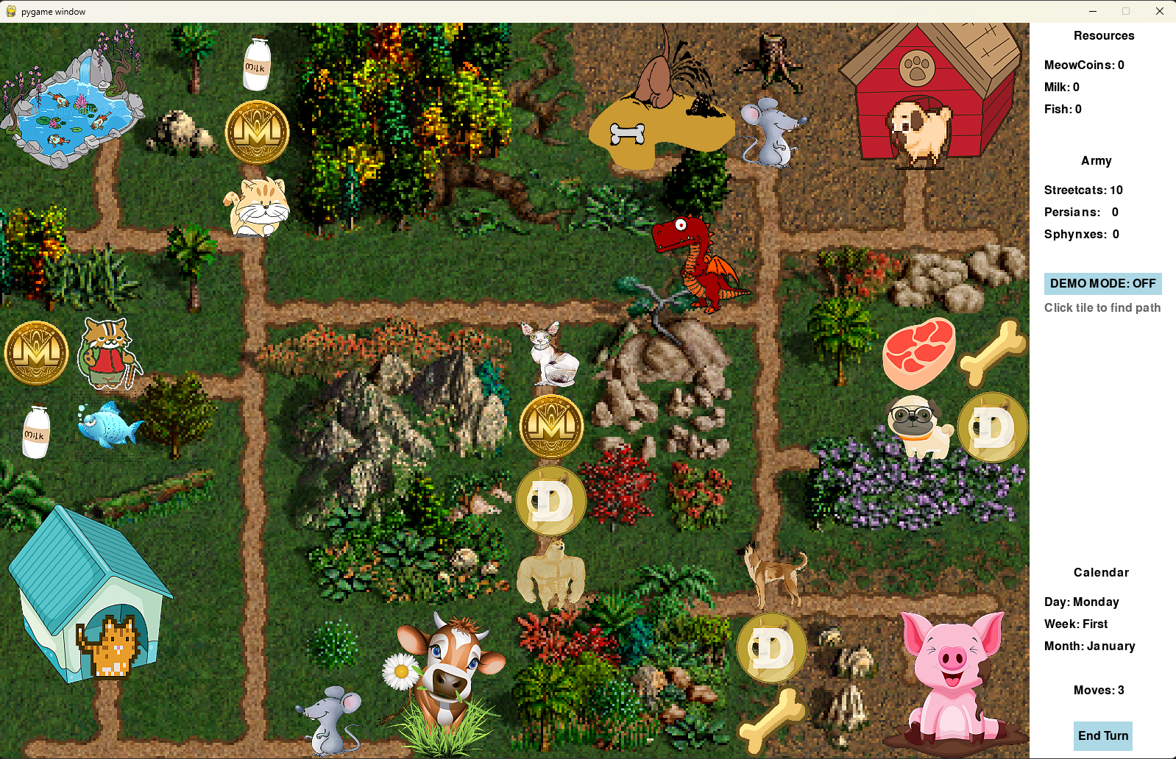
Figure 1: Start screen of the game PetWars

1. Theoretical part

1.1 Presentation of the selected algorithms
The project implements three algorithms for finding the shortest path in a graph:
- Dijkstra’s algorithm – a classical algorithm for graphs with non-negative edge weights
- A* algorithm – an extension of Dijkstra with a heuristic function
- Bellman–Ford algorithm – a general-purpose algorithm that also works with negative weights
These algorithms are fundamental in graph theory and are widely used in computer games, navigation systems, and network protocols.

1.2 Dijkstra’s algorithm
Dijkstra’s algorithm is a classical algorithm for finding the shortest path from a single source to all other vertices in a graph with non-negative edge weights. It was developed by the Dutch scientist Edsger Dijkstra in 1956.
Main idea and principle of operation:
- A set of visited vertices and a priority queue of unvisited vertices are maintained
- For each vertex the current shortest distance from the starting vertex is stored
- At each step the unvisited vertex with the smallest distance is chosen
- Distances to the neighbors of the selected vertex are updated
Definitions and mathematical model:
Let G = (V, E) be a graph with a set of vertices V and a set of edges E. For every edge (u, v) ∈ E there is a weight w(u, v) ≥ 0. The algorithm finds d[v] – the minimum distance from the starting vertex s to every vertex v ∈ V.
Applications:
- GPS navigation and routing
- Network protocols (OSPF)
- Computer games (AI pathfinding)
Complexity: O((V+E) log V), where V is the number of vertices and E is the number of edges.

1.3 A* algorithm
The A* algorithm is an extension of Dijkstra’s algorithm that uses a heuristic function to guide the search towards the goal. This makes it significantly more efficient in practical applications.
Main idea and principle of operation:
It uses the function f(n) = g(n) + h(n), where:
- g(n) is the actual cost from the start to the current vertex
- h(n) is the heuristic estimate from the current vertex to the goal
In the project the Octile distance is used as a heuristic, suitable for movement in 8 directions (including diagonal): h(n) = D · max(|dx|, |dy|) + (D₂ – D) · min(|dx|, |dy|), where D = 2 (orthogonal cost), D₂ = 3 (diagonal cost). This simplifies to: h(n) = 2 · max(|dx|, |dy|) + 1 · min(|dx|, |dy|).
The algorithm prioritizes vertices that are closer to the goal.
Definitions and mathematical model:
The heuristic function h(n) must be admissible, i.e. it must never overestimate the real distance to the goal. The Octile distance is an admissible heuristic for movement in 8 directions (4 orthogonal + 4 diagonal).
Applications:
- Computer games (the main algorithm for AI pathfinding)
- Robotics and autonomous vehicles
- Task planning
Complexity: O((V+E) log V) in the worst case, but in practice much faster than Dijkstra.

1.4 Bellman–Ford algorithm
The Bellman–Ford algorithm finds the shortest paths from a single source to all vertices and can also work with negative edge weights (unlike Dijkstra).
Main idea and principle of operation:
- Performs V–1 iterations, where V is the number of vertices
- At each iteration it "relaxes" all edges in the graph
- Relaxation means checking whether the path through a given edge is shorter
Definitions and mathematical model:
Relaxation of an edge (u, v): if d[u] + w(u, v) < d[v], then d[v] = d[u] + w(u, v). After V–1 iterations, if there are still edges that can be relaxed, the graph contains a negative cycle.
Applications:
- Network protocols (RIP, BGP)
- Detection of negative cycles
- Financial arbitrage
Complexity: O(V*E), which is slower than Dijkstra but more general.

1.5 Comparison of the algorithms
Algorithm | Complexity | Advantages | Disadvantages
Dijkstra | O((V+E) log V) | Optimal, reliable | Explores in all directions
A* | O((V+E) log V) | Guided search, fast | Requires a good heuristic
Bellman–Ford | O(V*E) | Works with negative weights | Slower
Table 1: Comparison of the algorithms
All three algorithms use movement in 8 directions with a weight of 2 for straight movement and 3 for diagonal movement.

1.6 A closer look at Dijkstra with an example graph
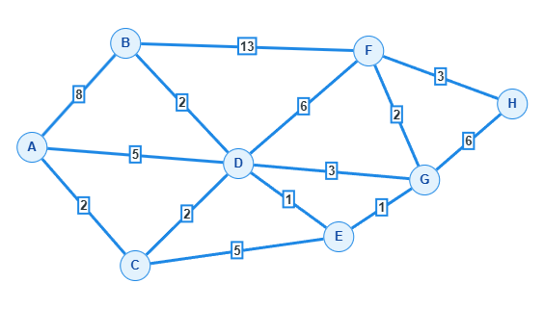
Figure 2: Example graph for demonstration of Dijkstra’s algorithm
V | A | B | C | D | E | F | G | H
A | 0ᴬ | 8ᴬ | 2ᴬ | 5ᴬ | ∞ | ∞ | ∞ | ∞
C |  | 8ᴬ | 2ᴬ | 4ᶜ | 7ᶜ | ∞ | ∞ | ∞
D |  | 6ᴰ |  | 4ᶜ | 5ᴰ | 10ᴰ | 7ᴰ | ∞
E |  | 6ᴰ |  |  | 5ᴰ | 10ᴰ | 6ᴱ | ∞
B |  | 6ᴰ |  |  |  | 10ᴰ | 6ᴱ | ∞
G |  |  |  |  |  | 8ᵍ | 6ᴱ | 12ᵍ
F |  |  |  |  |  | 8ᵍ |  | 11ᶠ
H |  |  |  |  |  |  |  | 11ᶠ
Table 2: Traversal of the graph with Dijkstra’s algorithm
Step-by-step description of how the algorithm works
Dijkstra’s algorithm works as follows:
- We start from the initial vertex A and set its distance to 0, and the distance to all other vertices to infinity.
- At each iteration we choose the unvisited vertex with the smallest current distance and "lock" it – that distance is final.
- After locking, we update the distances to all neighbors of the current vertex: if the path through it is shorter than the current one, we write the new value.
- We repeat steps 2–3 until we reach the target vertex or visit all vertices.
The index next to each number in the table shows through which vertex the currently shortest path passes.
Starting vertex: A, Target vertex: H
The numbers in the table represent the total distance from A to the corresponding vertex.
Iteration 1: We visit A
Distance to A = 0
We compute the cumulative distances to the neighbors: B: 0 + 8 = 8ᴬ C: 0 + 2 = 2ᴬ D: 0 + 5 = 5ᴬ E, F, G, H = infinity
Lock A = 0
Next: C (smallest = 2)
Iteration 2: We visit C
Distance to C = 2
We update the cumulative distances: D: min(5, 2+2) = 4ᶜ (shorter path through C) E: 2 + 5 = 7ᶜ
Lock C = 2
Next: D (= 4)
Iteration 3: We visit D
Distance to D = 4
We update the cumulative distances: B: min(8, 4+2) = 6ᴰ E: min(7, 4+1) = 5ᴰ F: 4 + 6 = 10ᴰ G: 4 + 3 = 7ᴰ
Lock D = 4
Next: E (= 5)
Iteration 4: We visit E
Distance to E = 5
We update the cumulative distances: G: min(7, 5+1) = 6ᴱ
Lock E = 5
Next: B (= 6, we pick B before G)
Iteration 5: We visit B
Distance to B = 6
We update the cumulative distances: F: min(10, 6+13) = 10ᴰ (no change, 19 > 10)
Lock B = 6
Next: G (= 6)
Iteration 6: We visit G
Distance to G = 6
We update the cumulative distances: F: min(10, 6+2) = 8ᵍ (G–F = 2) H: 6 + 6 = 12ᵍ
Lock G = 6
Next: F (= 8)
Iteration 7: We visit F
Distance to F = 8
We update the cumulative distances: H: min(12, 8+3) = 11ᶠ
Lock F = 8
Next: H (= 11)
Iteration 8: We visit H
Distance to H = 11
No unvisited neighbors
Lock H = 11
END
Result
Shortest path from A to H = 11
Path: A, C, D, E, G, F, H

2. Example of how the algorithms work
In PetWars the algorithms are used to find a path from the hero’s current position to a selected target tile on the map. The map is represented as a two-dimensional grid (14x10 cells), where each cell can be either walkable (value 1) or blocked (value 0).
Execution steps (illustrated with Dijkstra):
- Initialization: the starting position gets distance 0, all others – infinity
- Adding the starting position to the priority queue
- Extracting the vertex with the smallest distance from the queue
- For each neighbor (8 directions: 4 orthogonal + 4 diagonal, with cost 2 for orthogonal and 3 for diagonal movement)
- Repeating until the goal is reached or the queue is empty
- Reconstructing the path by backtracking from the goal to the start
In the game’s demo mode the visualization shows:
- Orange cells – visited vertices (already explored)
- Yellow cells – vertices in the queue (frontier)
- Red cell – the vertex currently being examined
- Blue cells – the resulting shortest path
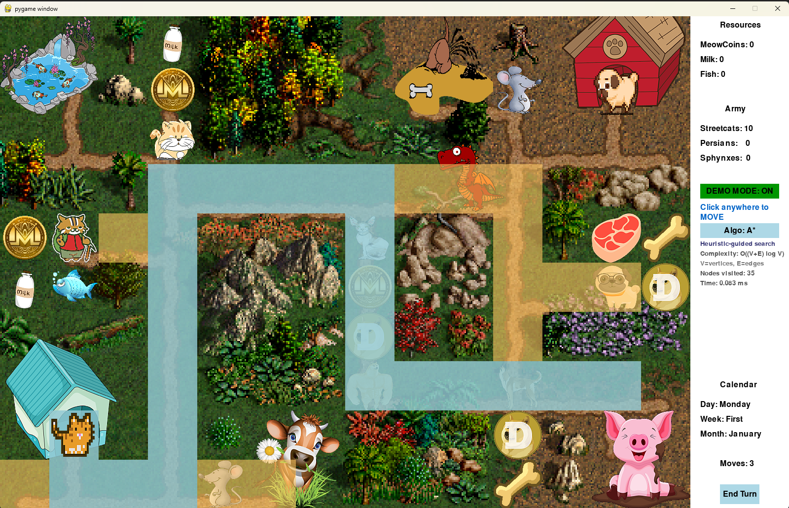
Figure 3: Visualization of the algorithm in demo mode before diagonal movement was introduced

3. Software implementation – https://github.com/hristogwivanov/PetWars
The project is implemented in Python using the Pygame library for the graphical interface. The main files are:
- main.py – the main file with the game loop and visualization
- pathfinding.py – implementation of the three algorithms
- gamedata.py – classes for heroes, resources and the AI opponent
- constants.py – constants, colors and terrain maps
- interface.py – UI components (buttons, turn counter)

3.1 Implementation of Dijkstra’s algorithm
def dijkstra_path(start, goal, terrain_map):
"""
Find shortest path using Dijkstra's algorithm.

Args:
start: Tuple (x, y) - starting position
goal: Tuple (x, y) - destination position
terrain_map: 2D list where 1 = walkable, 0 = blocked

Returns:
List of (x, y) tuples representing the path, or None if no path exists
"""
# Priority queue: (distance, (x, y))
open_set = [(0, start)]
# Track shortest distance to each node
g_score = {start: 0}
# Track path reconstruction
came_from = {}

while open_set:
# Get node with smallest distance (greedy choice)
current_dist, current = heapq.heappop(open_set)

# Goal reached - reconstruct path
if current == goal:
path = []
while current in came_from:
path.append(current)
current = came_from[current]
path.append(start)
return path[::-1]

# Skip if we've found a better path already
if current_dist > g_score.get(current, float('inf')):
continue

x, y = current
# Explore all neighbors (orthogonal + diagonal)
for nx, ny, cost in get_neighbors(x, y, terrain_map):
# Calculate new distance (2 for orthogonal, 3 for diagonal)
tentative_g = g_score[current] + cost

# Update if this path is better
if tentative_g < g_score.get((nx, ny), float('inf')):
came_from[(nx, ny)] = current
g_score[(nx, ny)] = tentative_g
heapq.heappush(open_set, (tentative_g, (nx, ny)))

return None # No path found

3.2 Implementation of A* with heuristic
def octile_heuristic(a, b):
dx = abs(a[0] - b[0])
dy = abs(a[1] - b[1])
D = 2 # orthogonal cost
D2 = SQRT2 # diagonal cost
return D * max(dx, dy) + (D2 - D) * min(dx, dy)

def astar_path(start, goal, terrain_map):
"""
Find shortest path using A* algorithm (instant version).
Uses octile heuristic for diagonal movement.
"""
open_set = [(octile_heuristic(start, goal), start)]
open_set_lookup = {start}
g_score = {start: 0}
came_from = {}
visited = set()

while open_set:
_, current = heapq.heappop(open_set)
open_set_lookup.discard(current)

if current in visited:
continue

visited.add(current)

if current == goal:
path = []
node = current
while node in came_from:
path.append(node)
node = came_from[node]
path.append(start)
return path[::-1]

x, y = current
# Explore all neighbors (orthogonal + diagonal)
for nx, ny, cost in get_neighbors(x, y, terrain_map):
if (nx, ny) in visited:
continue

tentative_g = g_score[current] + cost

if tentative_g < g_score.get((nx, ny), float('inf')):
came_from[(nx, ny)] = current
g_score[(nx, ny)] = tentative_g
f_score = tentative_g + octile_heuristic((nx, ny), goal)
if (nx, ny) not in open_set_lookup:
heapq.heappush(open_set, (f_score, (nx, ny)))
open_set_lookup.add((nx, ny))

return None

3.3 Implementation of Bellman–Ford
def bellman_ford_path(start, goal, terrain_map):
"""
Find shortest path using Bellman-Ford algorithm (instant version).
Bellman-Ford relaxes all edges V-1 times.
Supports diagonal movement (orthogonal cost 2, diagonal cost 3).
"""
# Build list of all edges from walkable tiles (including diagonals)
edges = []
vertices = set()
for y in range(MAP_HEIGHT):
for x in range(MAP_WIDTH):
if terrain_map[y][x] == 1:
vertices.add((x, y))
for nx, ny, cost in get_neighbors(x, y, terrain_map):
edges.append(((x, y), (nx, ny), cost))

# Initialize distances
dist = {v: float('inf') for v in vertices}
dist[start] = 0
came_from = {}

# Relax all edges V-1 times
for _ in range(len(vertices) - 1):
updated = False
for u, v, w in edges:
if dist[u] + w < dist[v]:
dist[v] = dist[u] + w
came_from[v] = u
updated = True
if not updated:
break

# Reconstruct path
if dist[goal] == float('inf'):
return None

path = []
node = goal
while node != start:
path.append(node)
node = came_from[node]
path.append(start)
return path[::-1]

4. Demonstration
Input data:
- Terrain map (14x10 cells) – defined in constants.py
- Starting position of the hero – bottom-left corner (1, 8)
- Target position – selected by a mouse click
Output data:
- Real-time visualization of the search process
- The shortest path found (shown in blue)
- Number of visited vertices
- Execution time (in milliseconds)
The demo mode is activated with the "DEMO MODE" button or the D key. In this mode the algorithm is visualized step by step with an adjustable speed (200 ms between steps). The user can choose between the three algorithms using the "Algo" button.
Game controls:
- Arrow keys – move the hero in 4 directions
- Mouse click – automatic pathfinding to the selected tile
- D – toggle demo mode, E – end turn
New features added during the course project:
- Movement points system – the hero has 10 movement points per turn (orthogonal = 2, diagonal = 3)
- Smooth path visualization – the path is drawn using Chaikin’s corner-cutting algorithm, which creates smooth arcs instead of sharp turns
- Diagonal movement – the hero can move in 8 directions

5. Testing the algorithms
To compare the three algorithms, tests were performed with three different distances: short, medium and long. For each test the execution time and the number of visited vertices were measured.

5.1 Short distance
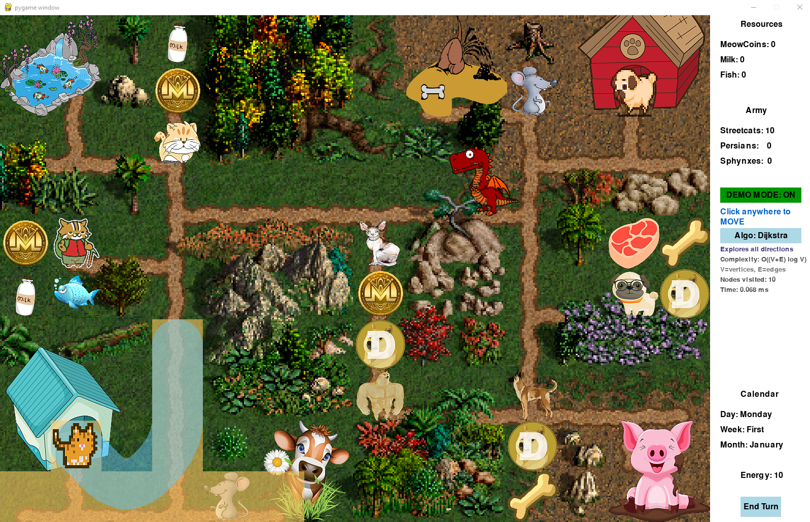
Figure 4: Visualization of Dijkstra’s algorithm at a short distance
Starting position: (9, 2) → Target position: (7, 4)
Algorithm | Time (ms) | Visited vertices | Path length
Dijkstra 1 | 0.068 | 10 | 10
Dijkstra 2 | 0.090 | 10 | 10
Dijkstra 3 | 0.073 | 10 | 10
A* 1 | 0.088 | 6 | 10
A* 2 | 0.077 | 6 | 10
A* 3 | 0.062 | 6 | 10
Bellman–Ford 1 | 0.617 | 59 | 10
Bellman–Ford 2 | 0.678 | 59 | 10
Bellman–Ford 3 | 0.792 | 59 | 10
Table 3: Test results at a short distance

5.2 Medium distance
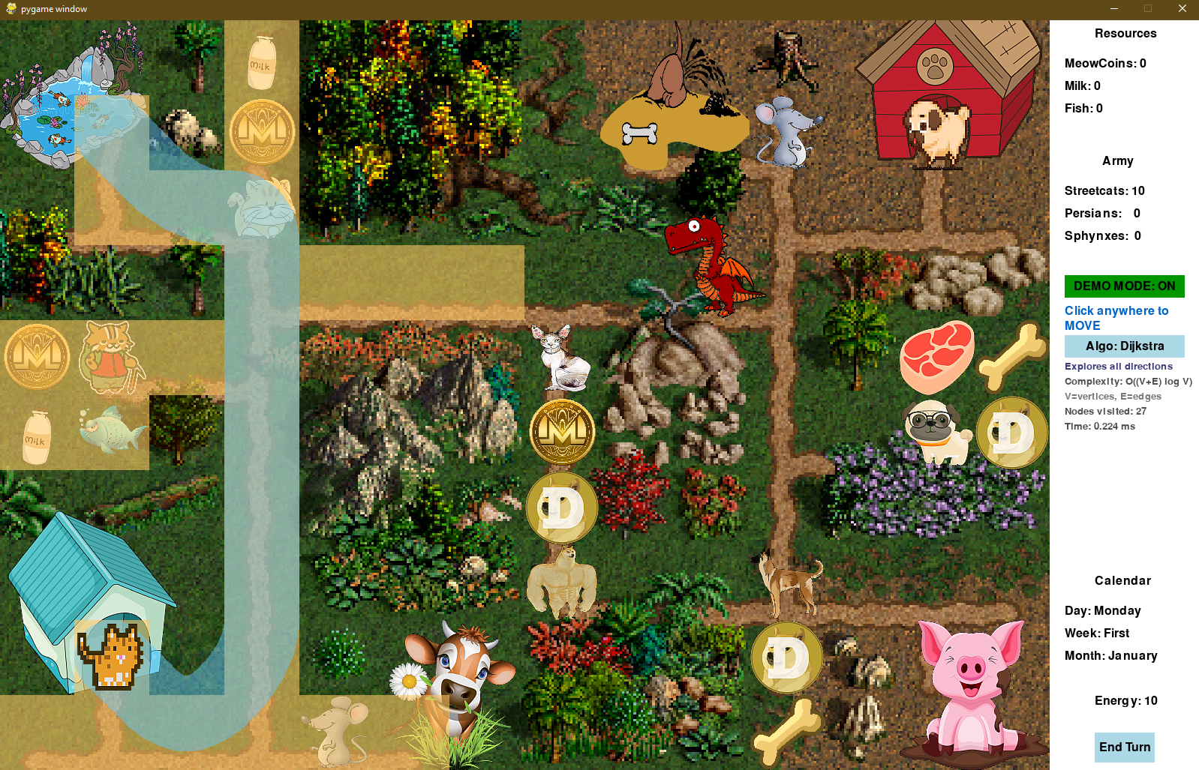
Figure 5: Visualization of Dijkstra’s algorithm at a medium distance
Starting position: (9, 2) → Target position: (2, 2)
Algorithm | Time (ms) | Visited vertices | Path length
Dijkstra 1 | 0.224 | 27 | 22
Dijkstra 2 | 0.185 | 27 | 22
Dijkstra 3 | 0.203 | 27 | 22
A* 1 | 0.161 | 16 | 22
A* 2 | 0.135 | 16 | 22
A* 3 | 0.131 | 16 | 22
Bellman–Ford 1 | 0.559 | 59 | 22
Bellman–Ford 2 | 0.564 | 59 | 22
Bellman–Ford 3 | 0.832 | 59 | 22
Table 4: Test results at a medium distance

5.3 Long distance
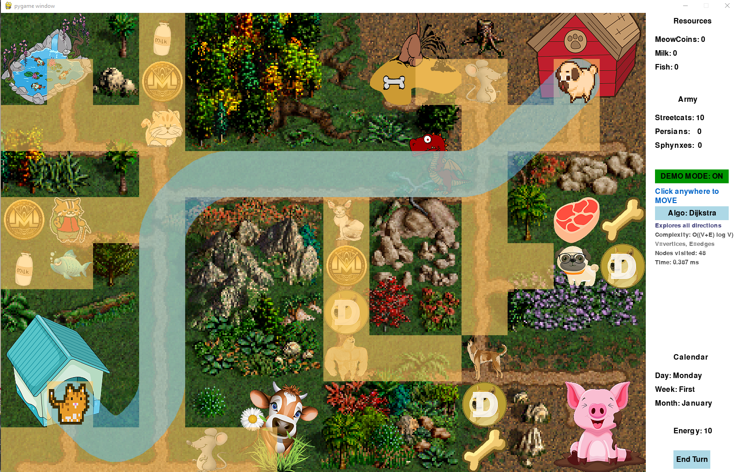
Figure 6: Visualization of Dijkstra’s algorithm at a long distance
Starting position: (9, 2) → Target position: (2, 13)
Algorithm | Time (ms) | Visited vertices | Path length
Dijkstra 1 | 0.387 | 48 | 35
Dijkstra 2 | 0.509 | 48 | 35
Dijkstra 3 | 0.383 | 48 | 35
A* 1 | 0.171 | 22 | 35
A* 2 | 0.168 | 22 | 35
A* 3 | 0.182 | 22 | 35
Bellman–Ford 1 | 0.825 | 59 | 35
Bellman–Ford 2 | 0.817 | 59 | 35
Bellman–Ford 3 | 0.639 | 59 | 35
Table 5: Test results at a long distance

5.4 Summary comparison table
Algorithm | Short Time (ms) | Short Vertices | Medium Time (ms) | Medium Vertices | Long Time (ms) | Long Vertices
Dijkstra | 0.077 | 10 | 0.204 | 27 | 0.426 | 48
A* | 0.076 | 6 | 0.142 | 16 | 0.174 | 22
Bellman–Ford | 0.696 | 59 | 0.652 | 59 | 0.760 | 59
Table 6: Summary of test results

5.5 Analysis of the results
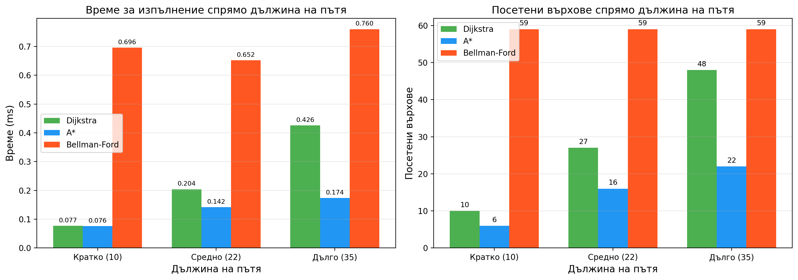
Figure 7: Summary of the test results
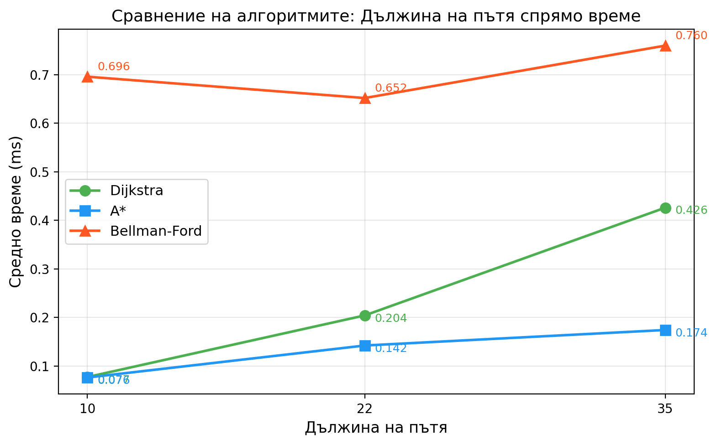
Figure 8: Line chart of the test results
The conducted tests reveal the following patterns:
A* is the fastest algorithm in all test scenarios. At a short distance, its time (0.076 ms) is comparable to Dijkstra (0.077 ms), but at a long distance the difference becomes significant – A* (0.174 ms) is more than twice as fast as Dijkstra (0.426 ms). This is due to the heuristic function (Octile distance), which directs the search towards the goal and avoids unnecessary exploration of vertices.
Dijkstra shows stable performance, but the number of visited vertices grows proportionally to the distance (from 10 to 48), because the algorithm explores uniformly in all directions. At a short distance the difference with A* is negligible, but on longer paths the inefficiency becomes visible.
Bellman–Ford is the slowest algorithm with a time between 0.652 and 0.760 ms. Characteristic for it is that the number of visited vertices stays constant (59) regardless of the distance, because the algorithm always traverses all edges in the graph. Despite its slower work, it is the only one of the three that can handle graphs with negative weights.
All three algorithms find an equally optimal path (the same length), which confirms the correctness of the implementations. For this particular application A* is clearly the most suitable choice, especially with a view to a future implementation of larger maps.

6. Conclusion
In the project three shortest-path algorithms have been successfully implemented: Dijkstra, A* and Bellman–Ford. The visualization in the context of the game PetWars makes it possible to observe the algorithms working in real time and to compare their efficiency.
Main results:
- A* is the fastest for a directed search towards a specific goal thanks to the heuristic function
- Dijkstra explores a larger area, but guarantees optimality in all cases
- Bellman–Ford is slower due to the O(V*E) complexity, but works with more general cases
Possibilities for future development:
- Adding different terrain weights (water, mountains, roads)
- Implementation of Jump Point Search for even faster search on grids
- Parallelization of the algorithms for larger maps

7. References
1. Cormen, T. H., Leiserson, C. E., Rivest, R. L., Stein, C. "Introduction to Algorithms", 3rd Edition, MIT Press, 2009
2. Russell, S., Norvig, P. "Artificial Intelligence: A Modern Approach", 4th Edition, Pearson, 2020
3. Pygame Documentation – https://www.pygame.org/docs/
4. Red Blob Games – Introduction to A* – https://www.redblobgames.com/pathfinding/a-star/
5. Dijkstra, E. W. "A note on two problems in connexion with graphs", Numerische Mathematik, 1959

